MATHLAB - Creating Multilingual Support for Windows Applications

Submitted By:
Mentor:
Mayank Goel,
Dr. Anand SN,
Research Intern,
ABB Corporate Research, India
ABB Corporate Research, India


1

Acknowledgements

On the very outset of internship at ABB Corporate Research India, It is my radiant sentiment to place on record my best regards, deepest sense of gratitude to Anand SN for his careful and precious guidance which are extremely valuable for my study both theoretically and practically. Without his active guidance, help, cooperation, and encouragement, I could not have made headway in the project.
I express my deepest thanks to Sudarsan SD and Pravin Kumar, for taking part in useful decision & giving necessary advices and guidance and arranged all facilities to make life easier. I choose this moment to acknowledge their contribution gratefully. I would like to express my deepest gratitude and special thanks to the Ravi Prakash and Devina Mohan who in spite of being extraordinarily busy with their duties, took time out to hear, guide and keep me on the correct path.
I extend my gratitude to ABB Corporate Research India for giving me this opportunity. I will strive to use gained skills and knowledge in the best possible way, and I will continue to work on their improvement, in order to attain desired career objectives.

2

Abstract

Working on softwares built with the focus on utility rather than scalability can be challenging because it involves dealing with the heterogeneity that exists in the language preferences across various work cultures. Secondly, programmers involved in the development of large scale applications have to address issues pertaining to diﬀerent life-cycles ranging from design, implementation to deployment. Making it compatible for overseas use may be easily ignored. Given the world emerging as a global community, a critical challenge is to build support applications to reduce the language barrier between the software and the Client using the software.

Several approaches to tackle this challenge have been proposed in the fields of UI Automation. However, existing approaches only cover limited subsets of the above mentioned challenges as they are developed to target text, image or audio data. In view of this, in this report, we have discussed about the existing frameworks as precursors to this framework for multilingual UI automation with substantial utility features for easy management and scalability in a high-level programming language, and we present a comparative evaluation result with existing approaches. This provides the UI Automation community for further benchmarking. The evaluation is carried out on PG 1000 software which has its UI in Japanese language. Our experimental analysis and results demonstrate that our approach makes it possible to work on such softwares without any dependence on the knowledge of the native tongue used in the software and thereby reduces the development effort for developers.

3

Contents

1 Introduction | 8
- Application example: Smart Home . . . . . . . . . . . . . . . . . . . . . . . . . . . . 8

- UI Automation application development challenges . . . . . . . . . . . . . . . . . . . . . . . . 8

1.3 State of the art: Programming UI Automation, Service and People . . . . . . . . 10

- Contributions . . . . . . . . . . . . . . . . . . . . . . . . . . . . . . . . . . . . . . . . 11

2 Diﬀerent development concerns | 12
2.1 Domain Concern . . . . . . . . . . . . . . . . . . . . . . . . . . . . . . . . . . . . . . | 12
- Functional Concern . . . . . . . . . . . . . . . . . . . . . . . . . . . . . . . . . . . . . 13

- Platform Concern . . . . . . . . . . . . . . . . . . . . . . . . . . . . . . . . . . . . . . 13

- Deployment Concern . . . . . . . . . . . . . . . . . . . . . . . . . . . . . . . . . . . . 14

 | 2.5 | Linking . . . . . . . . . . . . . . . . . . . . . . . . . . . . . . . . . . . . . . . . . . . | 14
3 | Specify Domain |  | 15
4 | Specify Architecture |  | 17
5 | Specify User-interactions |  | 19
6 | Specify Deployment |  | 20
7 | Application development using IoTSuite |  | 21
 | 7.1 | Create a IoTSuite Project . . . . . . . . . . . . . . . . . . . . . . . . . . . . . . . . . | 21
 |  | 7.1.1 Download IoTSuite-Eclipse-Plugin . . . . . . . . . . . . . . . . . . . . . . . . | 21
- Open IoTSuite Eclipse . . . . . . . . . . . . . . . . . . . . . . . . . . . . . . . . . . . 21

 | 7.3 | Create a new IoTSuite Project . . . . . . . . . . . . . . . . . . . . . . . . . . . . . . |  | 22
 |  | 7.3.1 | Specifying high-level specifications . . . . . . . . . . . . . . . . . . . . . . . . | 24
 | 7.4 | Compilation of an IoTSuite Project . . . . . . . . . . . . . . . . . . . . . . . . . . . . |  | 28
 |  | 7.4.1 | Compilation of high-level specification . . . . . . . . . . . . . . . . . . . . . . | 28
 | 7.5 | Deployment of generated packages . . . . . . . . . . . . . . . . . . . . . . . . . . . . |  | 34
8 | Evaluation |  |  | 35
9 | Real time PT 100 sensor data visualization using RIO600 |  |  | 37
10 | Conclusion and Future work |  |  | 41

5

List of Figures

- A smart home with deployed devices with (1) Temperature sensor, (2) Heater, (3) Fire

alarm, (4) Smoke Detector, (5) Badge reader, (6) Data storage, (7) Motion sensor,

and (8) Smoke sensor. . . . . . . . . . . . . . . . . . . . . . . . . . . . . . . . . . . . 9 2 UI Automation application development: the overall process . . . . . . . . . . . . . . . . . . . 12 3 Dataflow of Smart Home Application. . . . . . . . . . . . . . . . . . . . . . . . . . . 18
- Open IoTSuite Eclipse . . . . . . . . . . . . . . . . . . . . . . . . . . . . . . . . . . . 22

- Select default Workspace . . . . . . . . . . . . . . . . . . . . . . . . . . . . . . . . . . 22

- IoTSuite Project Creation Wizard (1) . . . . . . . . . . . . . . . . . . . . . . . . . . 23

7 | IoTSuite Project Creation Wizard (2) . . . . . . . . . . . . . . . . . . . . . . . . . . | 23
8 | IoTSuite Project Structure . . . . . . . . . . . . . . . . . . . . . . . . . . . . . . . . . | 24
- IoTSuite editor feature: Outline view . . . . . . . . . . . . . . . . . . . . . . . . . . . 25

- IoTSuite editor feature: Syntax coloring . . . . . . . . . . . . . . . . . . . . . . . . . 25

- IoTSuite editor feature: Code folding . . . . . . . . . . . . . . . . . . . . . . . . . . . 26

- IoTSuite editor features: Error checking & Auto completion . . . . . . . . . . . . . . 26

- Domain Specification . . . . . . . . . . . . . . . . . . . . . . . . . . . . . . . . . . . . 27

- Architecture Specification . . . . . . . . . . . . . . . . . . . . . . . . . . . . . . . . . 27

- User-Interaction Specification . . . . . . . . . . . . . . . . . . . . . . . . . . . . . . . 28

16 Deployment Specification . . . . . . . . . . . . . . . . . . . . . . . . . . . . . . . . . 28

- Compilation of Vocab specification . . . . . . . . . . . . . . . . . . . . . . . . . . . . 29

- Compilation of Architecture specification . . . . . . . . . . . . . . . . . . . . . . . . . 29

19 | Import application logic package . . . . . . . . . . . . . . . . . . . . . . . . . . . . . | 30
20 | Locate application logic package . . . . . . . . . . . . . . . . . . . . . . . . . . . . . . | 30
21 | Implement application logic package . . . . . . . . . . . . . . . . . . . . . . . . . . . | 31
22 | Compilation of User-Interaction specification . . . . . . . . . . . . . . . . . . . . . . | 31
23 | Compilation of Deployment specification . . . . . . . . . . . . . . . . . . . . . . . . . | 32
24 | Import user-interface project . . . . . . . . . . . . . . . . . . . . . . . . . . . . . . . | 32
25 | Locate user-interface project . . . . . . . . . . . . . . . . . . . . . . . . . . . . . . . . | 33
26 | Implement user-interface project . . . . . . . . . . . . . . . . . . . . . . . . . . . . . | 33
- Packages for target devices specified in the deployment specification . . . . . . . . . . 34

- Architecture of the system . . . . . . . . . . . . . . . . . . . . . . . . . . . . . . . . . 37

- RIO600 parameter configuration for RTD module using PCM600 . . . . . . . . . . . 38

30 | GOOSE communication configuration on RIO600 side . . . . . . . . . . . . . . . . . | 38
31 | Signal Matrix to subscribe for Analog Channel 1 . . . . . . . . . . . . . . . . . . . . | 39
32 | Mapping GOOSE configuration in REF620 . . . . . . . . . . . . . . . . . . . . . . . | 39
33 | Displaying temperature value through web-interface of RIO600 . . . . . . . . . . . . | 40
34 | Displaying Trend using Micro-SCADA . . . . . . . . . . . . . . . . . . . . . . . . . . | 40

6

List of Tables

1 Summary: existing approaches available for programming UI Automation application. . . . . 10 2 Smart home application implementation . . . . . . . . . . . . . . . . . . . . . . . . . 35
- Comparison of existing approaches: Lines of code required to develop the smart home application. S (Sensor), A (Actuator), T (Tag), WS (External Web Service),
EU (End user Application), ST (Storage),Comp. (Computational Services). . . . . 36

7

- Introduction

UI Automation is composed of highly heterogeneous interconnections of elements from both the Physical as well as Internet worlds. UI Automation include WSN, RFID technologies, smart phones, smart appliances as well as the elements of the traditional Internet such as Web and database servers, exposing their functionalists as Web services. In the UI Automation, things formed a network, things could be devices, vehicles, buildings, and other embedded objects that enable exchange of the data. A thing in the UI Automation is an entity which measures the Entity of Interest. For example, a smart watch is thing and measures the person’s body temperature, heart rate etc. Here person’s body temperature and heart rate are entity of interest for the entity smart watch. UI Automation applications will involve interactions among large numbers of devices, many of them directly interacting with their physical surroundings.

While UI Automation have shown a great potential of usage into several fields such as smart home, personal health, energy usage monitoring and others, the heterogeneity and diversity involved in UI Automation represent a diﬃcult challenge to deal with. An important challenge that needs to be addressed is to enable rapid development of UI Automation applications with minimal eﬀort by various stake holders¹ involved in the application development process. To address above issues, several challenges have already been addressed in the closely related fields of the Wireless Sensor Networks (WSNs) [9, p. 65]and pervasive computing [9, p. 65] to the modern day of UI Automation. The goal of our work [7] is to enable the development of applications for such complex systems. In the following, we discuss one of such application.

- Application example: Smart Home

To illustrate characteristics of UI Automation, we consider smart home applications. A home consists of several rooms, each one is instrumented with several heterogeneous entities (physical devices) for providing residents’ comfort, safety, and optimizing resources. Many applications can be developed on top of these devices, one of which we discuss below:
To accommodate a resident’s preference in a room, a database is used to keep the profile of each resident, including his/her preferred temperature level. An RFID reader in the room detects the resident’s entry and queries the database service. Based on this, the thresholds used by the room devices are updated. To ensure the safety of residents, a fire detection application is installed. It aims to detect fire by analyzing data from smoke and temperature sensors.
When fire occurs, residences are notified on their smart phones by an installed application. Additionally, residents and their neighbors are informed through a set of alarms. Moreover, the system generates the current environment status on dashboard (e.g., humidity, temperature, outside temperature by interacting with external web services) for the situation awareness.

- UI Automation application development challenges

The development of application (as discussed in the previous section) is diﬃcult because UI Automation exhibit the following challenges: Heterogeneous entities : An UI Automation may execute on a network consisting of diﬀerent types of entities. For example, a home consists of entities encompassing, sensors (e.g., temperature sensor), tags (e.g., BadgeReader to read a user’s badge), actuators (e.g.,

¹We use the term stakeholders as used in software engineering to mean- people, who are involved in the application development. Examples of stakeholders are software engineer, developer, domain expert, technologist etc.

8

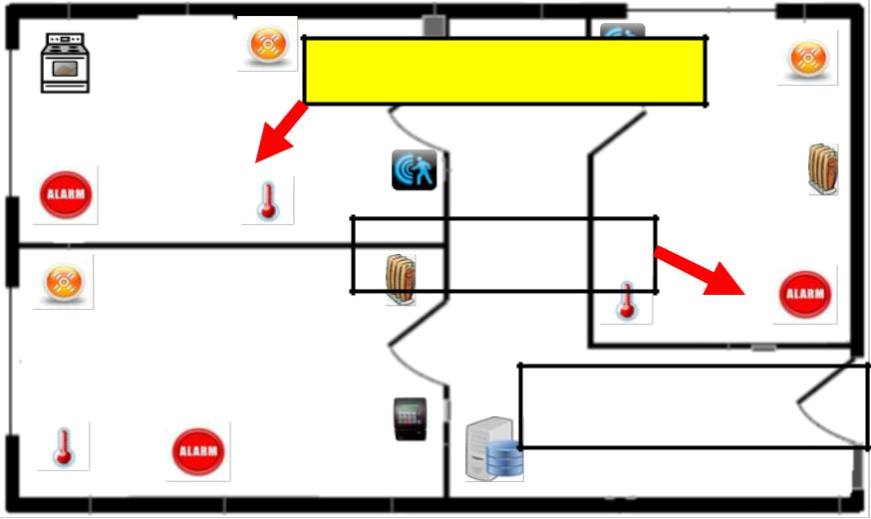
Turned on the alarm if smokeValue > 750
PPM and avgTempValue > 55

Room 1
(Kitchen) ^{Room 3}
(Meeting

 |  |  |  |  |  | Room)
 | Manage the heating of the
 |  | meeting room.
Room 2
(bedroom)
 |  |  |  | Monitor home environment
 |  |  |  | parameters: Temperature Value,
 |  |  |  | Humidity Value etc.
Motion sensor to detect the presence of a |  | Badge |  | Smoke |  | Data
 |  |  |  |  |  | storage
moving object |  | reader |  | Detector |  | storage
 |  |  |  |  |  | Temperature
 |  | Fire |  | Heater |  | Temperature
Stove to sense if it is turned on/off |  |  |  |  |  | sensor
 |  | alarm |  |  |  | sensor



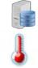

Figure 1: A smart home with deployed devices with (1) Temperature sensor, (2) Heater, (3) Fire alarm, (4) Smoke Detector, (5) Badge reader, (6) Data storage, (7) Motion sensor, and (8) Smoke sensor.

heater), user interfaces (e.g., user receives notification in case of fire), storage (e.g., profile storage to store users’ data), and elements of the “traditional” Internet such as Web and database servers, exposing their functionality as Web services (e.g., Yahoo Weather service).
Heterogeneous interaction modes: The above mentioned entities exhibit diﬀerent interaction modes such as event-driven (e.g., a smoke sensor fires when a smoke is detected), request-response (e.g., profile data is retrieved through request and response), periodic (e.g., temperature sensors sense data periodically), command [1] (e.g., a heater is commanded to regulate the temperature), and notify [2](e.g., a user is notified when the fire is detected).
Heterogeneous platforms: Unlike WSN, an UI Automation application may involve entities running on diﬀerent platforms. For instance, a temperature sensor may be attached with Raspberry PI, smoke sensor runs on a resource constrained micro-controller with no OS (e.g., Arduino), an end-user application is deployed on Android Mobile OS,and a dashboard is implemented using JavaScript and HTML.
Diﬀerent life cycle phases: Given the heterogeneity discussed above, Stakeholders have to address issues that are attributed to diﬀerent life cycles [8], including design, implementation, and deployment. At the design phase, the application logic has to be analyzed and separated into a set of distributed tasks for the underlying network consisting of heterogeneous entities. Then, these tasks have to be implemented for a specific platform of a device. At the deployment phase, the application logic has to be deployed onto a network of devices. Manual eﬀort in all above three phases for heterogeneous devices is a time-consuming and error-prone process.

9
Approach Description Examples Benefits Limitations

General

Purpose

Lang.

Developers think in terms of activities | Node.js, | Development of eﬃcient | • | More development eﬀort
of individual devices & explicitly en- | C, Python, | systems based on complete | • | Diﬃcult to reuse &
code interactions with others in pro- | Android | control over device. | platform-dependent design.
gramming language.

WSN macro prog.

It provides an ability to specify an ap- | Regiment | • | Flexibility to write cus- | Largely targets for similar
plication at a global level rather than | [6], | tom application logic. |  | types of devices.
individual nodes. | MacroLab | • | Reduce development
 |  | eﬀort.

Cloud | • Devices are connected to cloud plat- | Node-RED, | • Reduce development | • Platform-dependent
Platforms | forms through APIs or high-level (e.g., | WoTKit [3] | eﬀorts compared to GPLs. | design.
 | drag-and-drop) constructs. |  | • Oﬀers ease in applica- | • Scarifies direct node-to-
 | • Data from connected devices are |  | tion deployment and evolu- | node communication.
 | collected or shared for their own appli- |  | tion. | • Restricts developers in-
 | cations. |  |  | terms of functionality.
 | • they provide flexibility to write cus- |  |  | • May not suitable for
 | tom application logic in GPL such as |  |  | some critical applications.
 | JavaScript.

Model-driven Dev.

It separates diﬀerent concerns of a sys-tem at a certain level of abstractions and provides transformation engines to convert them to target platforms.

DiaSuite | , Re-usable, | Platform- | Long development time to
[4] | , Re-usable, | Platform- | Long development time to
[4] | indepe- ndent, | Extensible | build a MDD system.
PervML [8] | indepe- ndent, | Extensible | build a MDD system.
PervML [8] | design.

Table 1: Summary: existing approaches available for programming UI Automation application.

- State of the art: Programming UI Automation, Service and People

To address the above mentioned challenges, several approaches have been proposed in the closely related fields of WSN, Pervasive Computing, and Software Engineering. These approaches are summarized in Table 1.
Currently, development of UI Automation is performed at the node level, by experts in embedded and dis-tributed systems, who are directly concerned with operations of each device individually. They think in terms of activities of individual devices and explicitly encode their interactions with other devices. For example, they write a program that reads data from appropriate sensor devices, aggregates data pertaining to the some external events, decides where to send it and communicates with actuators if needed. For instance, stakeholders use General-purpose Programming Languages (GPLs) such as C, JavaScript, Android and target a particular middle-ware API to develop an application. The key advantage of such approach is that it allows the development of extremely eﬃcient systems based on the complete control over individual devices. However, it is unwieldy for UI Automation application due to the inherent heterogeneity of systems.

To reduce development eﬀort, an alternative approach is WSN macro-programming. It provides abstractions to specify high-level collaborative behaviors, while hiding low-level details such as message passing or state maintenance from stakeholders. Macro-programming is a viable approach compared to the general-purpose programming approaches. However, most of macro-programming systems largely aims to systems with similar types of nodes. Therefore, given heterogeneity this approach may not be viable. To address the heterogeneity issue and improve development eﬀort over GPLs, the Cloud-based platforms have emerged. It reduces development eﬀorts by providing cloud-based APIs to implement common functionality. As a secondary advantage, because of the application logic is centrally located in a cloud platform, it oﬀers the ease deployment and evolution. However, some limitations of this approach are: first, stakeholders have to write code to implement

10

low-level details such as reading values from sensors and actuating actuators. This again leads to a platform-dependent design. Second, it restricts developers in-terms of functionality such as “in-network” aggregation or direct node-to-node communication locally. To address development eﬀort and platform-dependent design issues, Model-driven development (MDD) [5] has been proposed. Several MDD frameworks [4, 8] have been proposed for programming UI Automation. However, existing approaches only cover limited subsets of challenges when applied to the UI Automation such as support for development life-cycles and usual behaviors found in modern UI Automation – such as remote access to Web services, interaction by a human user with software, and database access. By following the MDD guidelines, many benefits can be achieved. For instance, by separating diﬀerent concerns of a system at a certain level of abstractions and by providing transformation engines to convert these abstractions to target platforms lead to platform-independent design and improve productivity (e.g., re-usability, extensibility) in the application development process.

- Contributions

In view of the above, we have built upon our existing MDD development framework [7] and evolved it into a framework for UI Automation. The proposed development framework segregates UI Automation development concerns, provides a set of modeling languages to specify them and integrates automation techniques to parse these modeling languages. we present an enhanced and extended version of modeling languages and their integration into a development framework: (1) Domain language (DL) that models UI Automation characteristics such as describing heterogeneous entities such as tags, external third-party services, and diﬀerent types of sensors. (2) Architecture Language (AL) to describe functionality of an application, (3) User Interaction Language (UIL) to model interaction between an application and a user, and (4) Deployment Language (DL) to describe deployment-specific features consisting information about a physical environment where devices are deployed.

We present a comparative evaluation results with existing approaches. This further provides the UI Automation community for benchmarking. The evaluation is carried out on real devices exhibiting UI Automation heterogeneity. The evaluation shows that the use of modeling languages reduces user-written lines of code by more than 70% in comparison to an implementation in GPLs and 30% compared to cloud-based approaches.

11

- Diﬀerent development concerns

This section presents our development framework that separates UI Automation application development into diﬀerent concerns, namely domain, platform, functional, and deployment. It integrates a set of high-level modeling languages to specify such concerns. These languages are supported by automation techniques at various phases of application development process. Stakeholders carry out the following steps in order to develop a UI Automation application using our approach.
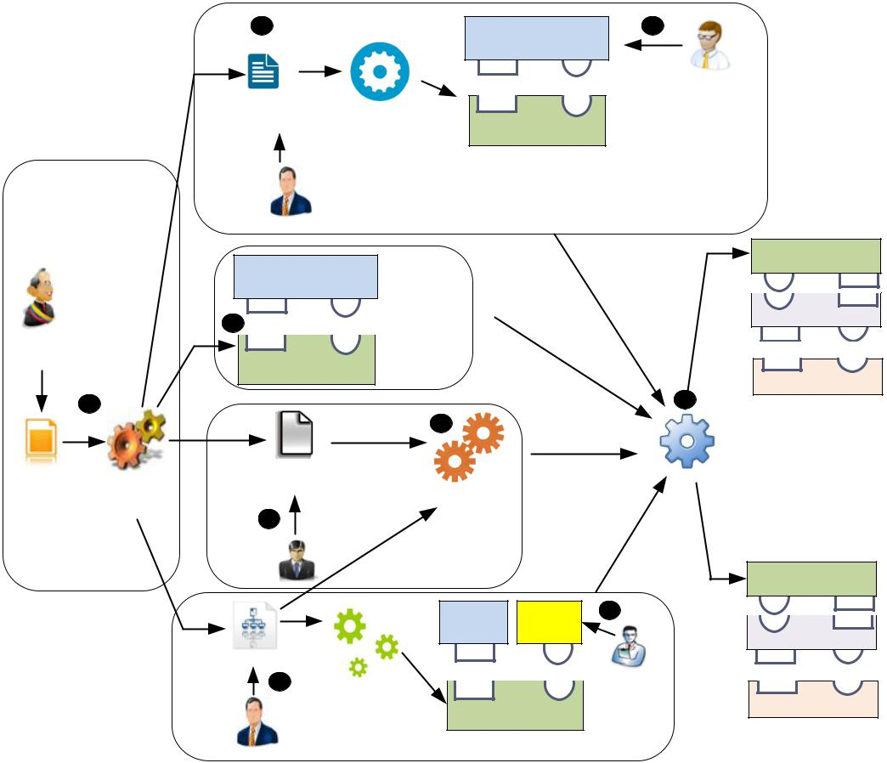

 |  | 5 |  |  |  |  | User Interface (UI) |  | 6
 |  |  |  |  |  |  |  | Code
 |  |  |  |  |  |  |  |  | User Interface
 |  | User Interaction |  |  | Compilation of |  |  |  | Designer
 |  | Spec. |  |  |  |  |  | UI framework
 |  |  |  | User interaction Spec |  |  |  | UI framework
 |  | Software |  |  |  |  |  | Platform
Domain |  | Designer |  |  |  |  |  | Platform
 |  |  |  |  |  |  |  | concern
concern |  |  |  |  |  |  |  | concern
 |  | Sensor, Actuator, |  |  |  |  |  |  |  | Generated code
 |  |  |  |  |  |  |  |  |  | For device N
 |  |  | Storage
 |  | Framework
 |  | 4 |  |  |  |  |  |  |  | Wrapper
Domain |  | 4 |  |  |  | Platform
expert
expert |  |  | Domain |  |  | concern
 |  | Framework
 |  |  |  |  |  |  |  |  |  | Runtime System
 | 1 |  |  |  |  |  |  |  | 9 | Runtime System
 | 1 |  |  |  |  |  | 8 |  | 9
 |  |  |  |  |  |  | 8 | Mapping
 |  |  |  |  |  |  |  | files
Domain | Compilation of | Deployment |  |  |  |  |  |  | Linker
Domain | Compilation of |  | Spec. |  |  |  |  |  | Linker
Spec. | Compilation of |  |  |  |  |  | Mapper |  | Linker
Spec. | Domain Spec. |  |  |  |  |  | Mapper
 |  | 7
 |  | Network |  |  |  | Deployment
 |  | Manager |  |  |  |  | concern |  |  | Generated code
 |  |  |  |  |  |  |  |  |  | For device N
 |  |  |  |  |  |  | In-Built | Custom | 3
 |  |  |  |  |  |  | Framwrk | Code |  | Wrapper
 |  | Architecture |  |  |  |  |  |  |  | Wrapper
 |  | Spec.
 |  | 2 |  | Compilation of |  |  |  |  | Application
 |  |  |  |  |  |  | Architecture |  | Developer | Runtime System
 |  | Software |  |  | Architecture |  |  |  |  | Runtime System
 |  | Designer |  |  |  | Spec. | Framework
Functional concern

Figure 2: UI Automation application development: the overall process

- Domain Concern

This concern is related to concepts that are specific to a domain (e.g., building automation, transport) of an UI Automation. The stakeholders task regarding such concern consists of the following step:
Specifying and compiling domain specification. The domain expert specifies a domain specifi-cation using the Domain Language (DL) (Step 1 in Figure 2). The domain specification includes specification of resources, which are responsible for interacting with Entities of Interest (EoI). This includes tags (identify EoI), sensors (sense EoI), actuators (aﬀect EoI), and storage (store information about EoI). In the domain specification, resources are specified in a high-level manner to abstract low-level details from the domain expert (detail in Section 3).


12

- Functional Concern

This concern is related to concepts that are specific to functionality of an UI Automation. An example of a functionality is to open a window when an average temperature value of a room is greater than 30 C. The stakeholders task regarding such concern consists of the following steps:

Specifying and compiling application architecture. Referring the domain specification, the software designer specifies an application architecture using the Architecture Language (AL)(Step 2 in Figure 2). It consists of specification of computational services and interaction among them (detail in Section 4). A computational service is fueled by sensors and storage defined in the domain specification. They process inputs data and take appropriate decisions by triggering actuators defined in the domain specification. The architecture specification consists of two types of computational services: (1) common specifies common operations such as average, count, sum in the application logic, (2) custom specifies an application-specific logic (for instance, coordinating events from BadgeReader with the content of Profile data storage).
- Platform Concern

This concern specifies the concepts that fall into computer programs that act as a translator between a hardware device and an application. The stakeholders task regarding such concern consists of the following steps:

Generating device drivers. The compilation of domain specification generates a domain frame-work (Step 4 in Figure 2). It contains concrete classes corresponding to concepts defined in the domain specification. The concrete classes contain concrete methods to interact with other software components and platform-specific device drivers, described in our work [7, p. 75]. We have integrated existing open-source sensing framework² for Android devices. Moreover, we have implemented sensing and actuating framework for Raspberry Pi and storage framework for MongoDB, MySQL, and Microsoft AzureDB. So, the device developers do not have to implement platform-specific sensor, actuator, and storage code.
Specifying user interactions. To define user interactions, we present a set of abstract interactors, similar to work [2], that denotes information exchange between an application and a user. The software designer specifies user interactions using User Interaction Language (UIL) (Step 5 in Figure 2). The UIL provides three abstract interactors: (1) command denotes information flow from a user to an application (e.g., controlling a heater according to a temperature preference), (2) notify denotes information flow from an application to a user (e.g., fire notification in case of emergency),
(3) request denotes information flows round-trip between an application and a user, initiated from the user (e.g., requesting preference information to a database server). More detail is in Section 5. The Implementation of user-interaction code is divided into two parts: (1) compilation of user-interaction specification, and (2) Writing user-interaction code. These two steps are described below:

- Compilation of user interaction spec: Leveraging the user interaction specification, the development framework generates a User Interface (UI) framework to aid the user interface designer (step 6 in Figure 2). The UI framework contains a set of interfaces and concrete classes corresponding to resources defined in the user interaction specification. The concrete
²http://www.funf.org/

13

classes contain concrete methods for interacting with other software components. For in-stance, the compilation of command interactors generates sendCommand() method to send command to other component. Similar way, the compilation of notify interaction generates notifyReceived() method to receive notifications.

  - Writing user-interaction code: Leveraging the UI framework, the user interface designer implements interfaces. These interfaces implements code that connects appropriate UI elements and concrete methods. For instance, a user initiates a command to heater by pressing UI elements such as button and sendCommand() method, or the application notifies a temperature value on textlabel through notifyReceived() method.

- Deployment Concern

This concern is related to deployment-specific concepts that describe the information about a device and its properties placed in the target deployment. It consists of the following steps:

Specifying target deployment. Referring the domain specification, the network manager describes a deployment specification using the Deployment Language (DL) (Step 7 in Figure 2). The deployment specification includes the details of each device, resources hosted by each devices, and the type of device. Ideally, the UI Automation application can be deployed on diﬀerent deployments. This requirement is dictated by separating a deployment specification from other specifications.
Mapping. The mapper produces a mapping from a set of computational services to a set of devices. It takes a set of devices defined in the deployment specification and a set of computation components defined in the architecture specification(Step 8 in Figure 2). The mapper devices devices where each computational services will be deployed. The current version of mapper algorithm [7] selects devices randomly and allocates computational services to the selected devices.
- Linking

The linker combines the code generated by various stages and creates packages that can be deployed on devices (Step 9 in Figure 2). It merges generated architecture framework, UI framework, domain framework, and mapping files. This stage supports the application deployment phase by producing device-specific code to result in a distributed software system collaboratively hosted by individual devices, thus providing automation at the deployment phase.
The final output of linker is composed of three parts: (1) a runtime-system runs on each individual device and provides a support for executing distributed tasks, (2) a device-specific code generated by the linker module, and (3) a wrapper separates generated code from the linker module and underlying runtime system by implementing interfaces.

14

- Specify Domain

The Domain Language (DL) oﬀers high-level constructs to specify the domain-specific concepts. We describe these constructs as follows:
Sensors A set of sensors is declared using the sensors keyword (Listing 1, line 6). Each sensor produces one or more sensor measurements along with the data-types specified in the data structure (Listing 1, lines 2-4), declared using the generate keyword (Listing 1, line 9). We categorize sensors into the following three types:

- Periodic sensor: It samples results every d seconds for a duration of k seconds. For instance, a temperature sensor generates a temperature measurement of TempStruct type (Listing 1, lines 2-4). It samples data every 1 second for next 6 minutes (Listing 1, line 10).

- Event-driven sensor: It produces data when the event condition is met. For instance, a smoke sensor generates smokeMeasurement when smokeValue > 650 PPM (Listing 1, lines 13-14).

- Request-based sensor: It responds its results only if it is requested. For instance, the YahooWeatherService provides temperature value of a location given by a locationID (List-ing 1, lines 15-18).

Tag It is a physical object that can be applied to or incorporated into Entities of Interest for the purpose of identification. It is read through a reader. For instance, a BadgeReader read an user’s badge and generates badgeDetectedStruct measurement (Listing 1, lines 20-21).
Actuators A set of actuators is declared using the actuators keyword (Listing 1, line 22). Each actuator has one or more actions declared using the action keyword. An action may take inputs specified as parameters (Listing 1, line 25). For instance, a heater may have two actions (e.g., switch oﬀ, set heater), illustrated in Listing 1, lines 23-25.
Storage A set of storage is declared using the storages keyword (Listing 1, line 26). A retrieval from the storage requires a parameter, specified using the accessed-by keyword (Listing 1, line 28). The data insertion into the storage is performed by the action keyword with parameter. For instance, a user’s profile is accessed from storage by a badgeID and inserted by invoking an action (Listing 1, line 29).

Listing 1: Code snippet of domain spec.

1 structs :

2 TempStruct

- tempValue : double ;

4 unitOfMeasurement : String ;

5 resources :

6 sensors :

- periodicSensors :

- TemperatureSensor

9 generate tempMeasurement : TempStruct ;

- sample period 1000 for 6 0 0 0 0 0 0 ;

- eventDrivenSensors :

- SmokeDetector

15

- generate smokeMeasurement : SmokeStruct ;

- onCondition smokeValue >650PPM;

- requestBasedSensors :

- YahooWeatherService

17 | generate weatherMeasurement : TempStruct accessed by
18 | l o c a t i o n I D : String ;
- tags :

- BadgeReader

- generate b a d g e D e t e c t e d S t r u c t : BadgeStruct ;

- actuators :

- Heater

- action Off ( ) ;

- action SetTemp ( setTemp : TempStruct ) ;

- storages :

- P r o f i l e D B

28 | generate p r o f i l e : TempStruct accessed by badgeID : String ;
29 | action I n s e r t P r o f i l e D a t a ( p r o f i l e D a t a : P r o f i l e S t r u c t ) ;

16

- Specify Architecture

Referring the concepts defined in the domain specification, the software designer specifies an architecture specification. It is described as a set of computational services. It consists of two types of computational services: (1) Common components specify common operations (e.g., average, count, sum) in the application logic. For instance, RoomAvgTemp component consumes 5 temperature measurements (Listing 2, line 4), apply average by sample operation (Listing 2, line 5), and generates room average temperature measurements (Listing 2, line 6). (2) Custom specifies an application-specific logic. For instance, Proximity component is a custom component (in Figure 3) that coordinates events from BadgeReader with the content from ProfileDB.

Each computational service is described by a set of inputs and outputs. We describe them below:

Consume and Generate. They represent a set of subscriptions (or consume) and publica-tions (or generate) expressed by a computational service. For instance, RoomAvgTemp consumes tempMeasurement (Listing 2, line 4), calculates an average temperature (Listing 2, line 5) and generates roomAvgTempMeasurement (Listing 2, line 6).

Request. It is a set of requests issued by a computational service to retrieve data. For instance, to access user’s profile, Proximity (Listing 2, line 10) sends a request message containing profile information as an access parameter to a storage ProfileDB (Listing 1, lines 27-29).

Command. It is a set of commands, issued by a computational service to trigger actions. The software designer can pass arguments to a command depend on action signature. For instance, the RoomController issues a SetTemp command(Listing 2, line 15) with a settemp as an argument to Heater (Listing 1, lines 23-25).
Figure 3 shows a layered architecture of the application discussed in Section 1.1. Listing 2 describes a part of Figure 3. It revolves around the actions of the Proximity service (Listing 2, lines 8-11), which coordinates events from the BadgeReader with the content of ProfileDB storage service. To do so, the Proximity composes information from two sources, one for badge events, and one for requesting the user’s temperature profile from ProfileDB. The output of the Proximity and RoomAvgTemp are consumed by the RoomController service (Listing 2, lines 13-14). This service is responsible for taking decisions that are carried out by invoking command (Listing 2, line 15).

Listing 2: A code snippet of architecture spec.

1 computationalServices :

2 Common:

- RoomAvgTemp

- consume tempMeasurement from TemperatureSensor ;

- COMPUTE(AVG_BY_SAMPLE, 5 ) ;

- generate roomAvgTempMeasurement : TempStruct ;

7 Custom:

- Proximity

- consume badgeDetected from BadgeReader ;

10 request p r o f i l e ( badgeID ) to P r o f i l e D B ;

- generate tempPref : UserTempPrefStruct ;

- RoomController

- consume roomAvgTempMeasurement from RoomAvgTemp ;

- consume tempPref from Proximity ;

17

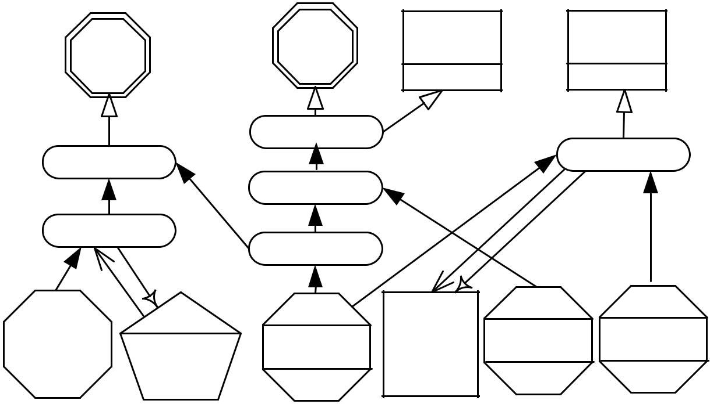

Heater | Alarm | EndUserApp | DashBoard
 | Fire Controller
RoomController |  |  | DataVisualizer
 | Fire State
Proximity
 | RoomA vgTemp

Badge |  | Temperature | Yahoo
Badge |  | Temperature | Weat her
Reader |  | Sensor | Weat her
Reader | ProfileDB | Sensor | Service

Smoke Humidity
Sensor Sensor

Legend
 |  |  |  |  |  |  | X | Y | X | Y | X | Y
RFID | Computational |  |  |  |  | Third-Party | X publishes data |  | X commands Y |  | X requests Y,
RFID | Computational |  |  |  | User | Third-Party | and Y subscribes |  | X commands Y |  | Y replies X
RFID | Computational | Sensor |  | Actuator | User | Third-Party |  |  |  |  | Y replies X
Reader | Service | Sensor | Storage | Actuator | interface | Web service
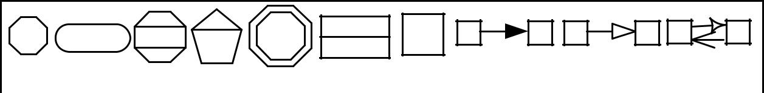

Figure 3: Dataflow of Smart Home Application. 15 command SetTemp ( setTemp ) to Heater ;

18

- Specify User-interactions

The user interactions specification defines what interactions are required by an application. We design a set of abstract interactors that denotes data exchange between an application and a user. The following are abstract interactors that are specified using User Interaction Language (UIL).

Command It denotes information flow from a user to an application. It is declared using the command keyword (Listing 3, lines 8-9). For instance, a user can control an actuator by triggering a Off() command (Listing 3, line 8). Command could be parametrized too. For instance, a user can set a temperature of heater by triggering a SetTemp() command (Listing 3, line 9).

Notify It denotes information flow from an application to a user. For instance, an application notifies a user in case of fire. It is declared using the notify keyword (Listing 3, lines 11-12). The application notifies users with the fire information specified in the data structure (Listing 3, lines 2-4).

Request It denotes information flow round-trip between an application and a user, but initiated from the user. For instance, a user can retrieve data by requesting to data storage. This is declared using the request keyword. The user requests ProfileDB for data (Listing 3, line 10) and the ProfileDB responses back with data to the user.

Listing 3: Code snippet of user interaction spec.

1 structs :

2 F i r e S t a t e S t r u c t

- f i r e V a l u e : String ;

4 | timeStamp : String ;
5 | resources :
6 | userInteractions :

- EndUserApp

8 command Off ( ) to Heater ;

- command SetTemp ( setTemp ) to Heater ;

10 | request p r o f i l e to P r o f i l e D B ;
11 | notify F i r e N o t i f y ( f i r e N o t i f y : F i r e S t a t e S t r u c t )
12 | from F i r e C o n t r o l l e r ;

- DashBoard

- notify DisplaySensorMeasurement ( sensorMeasurement : V i s u a l i z e S t r u c t )

15 from D i s p l a y C o n t r o l l e r ;

19

- Specify Deployment

The deployment specification describes a device and its properties in a target deployment. It includes properties such as location that defines where a device is deployed, resource defines component(s) to be deployed on a device, language-platform is used to generate an appropriate package for a device, protocol specifies a run-time system installed on a device to interact with other devices. Listing 4 shows a small code snippet to illustrate these concepts. TemperatureMgmt-Device-1 is located in room#1 (line 4), TemperatureSensor and Heater are attached with the device (line 5) and the device driver code for these two components is in NodeJS (line 6), MQTT runtime system is installed

on TemperatureMgmt-Device-1 device (line 7).

A storage device contains the database field that specifies the installed database. This field is used to select an appropriate storage driver. For instance, DatabaseSrv-Device-2 (lines 8-10) runs ProfileDB component implemented in MySQL database.
When an application is deployed, the network manger decides what user interaction components need to be deployed on devices. The announcement of user interaction components in the deployment specification is now an integral part of the specification. This announcement is used to deploy the generated UI framework and UI code (Step 5 in Figure 2) on a device. Listing 4 illustrates a code snippet to describes this concept. SmartPhone-Device-3 announces that EndUserApp (specified in user interaction specification) should be deployed on Android device (Lines 11-13).
Listing 4: Code snippet of deployment spec.

1 devices :

- TemperatureMgmt Device 1:

- location :

4 | Room : |  | 1 ;
5 | resources : |  | TemperatureSensor , Heater ;
6 | language platform : NodeJS ;
7 | protocol | : | mqtt ;
- DatabaseSrv Device 2:

9 resources : P r o f i l e D B ;

- database : MySQL;

- SmartPhone Device 3:

- resources : EndUserApp ;

- language platform : Android ;

- . . .

20

- Application development using IoTSuite

This section describes each step of UI Automation, Service, and People (UI Automation) application development process using IoTSuite. Application development using IoTSuite focuses on design, implement, and deployment phases to develop UI Automation applications.
We take an example of smart home application (Refer Figure 3) to demonstrate application development using IoTSuite.

- Create a IoTSuite Project

To develop a smart home application (Refer Figure 3) using IoTSuite, developers carry out the following steps.

7.1.1 Download IoTSuite-Eclipse-Plugin

- Download IoTSuite-Eclipse-Plugin ³.

- Go to Downloads folder.

- Extract downloaded IoTSuite-Eclipse-Plugin into C:n drive.

- Go to C:nIoTSuite-Eclipse-PluginnTemplate.

- Extract IoTSuite-TemplateV9-master.rar in to same directory (C:nIoTSuite-Eclipse-PluginnTem-plate).

7.2 Open IoTSuite Eclipse

- Go to C:nIoTSuite-Eclipse-Plugin.

- Right click on IoTSuite-Eclipse.exe as shown in Figure 4 (Step 1), and select Open option (Step 2).

- When IoTSuite-Eclipse is open, usually developers have to select workspace but here developers don’t need to go to C:nIoTSuite-Eclipse-PluginnTemplate in order to select workspace, it is already provided as default workspace.

- Just check on “Use this as the default and do not ask again” (Step 1) in and Click on OK button (Step 2) (Refer Figure 5).

³IoTSuite Eclipse Plugin is available at https://codebits.pl.abb.com/saurabh-internshhip-work

21

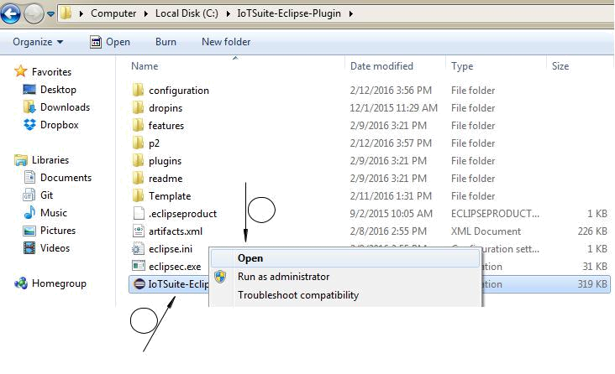

Select Open

2

1

Right click on

IoTSuite-Eclipse.exe

Figure 4: Open IoTSuite Eclipse

By default
Workspace
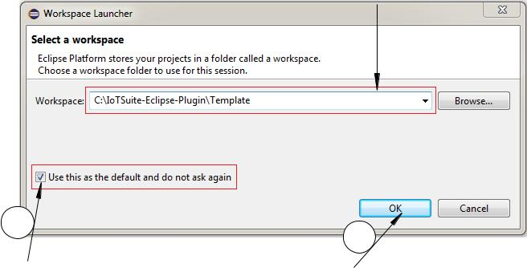

1
2

Check here Click on OK

Figure 5: Select default Workspace

7.3 Create a new IoTSuite Project

- To create a new IoTSuite project using IoTSuite-Eclipse, click File>New>Project.. , choose IoTSuite Project from the list (Refer Figure 6).

22

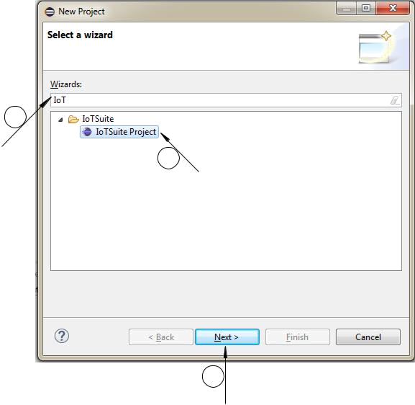

1

Search for IoT | 2
 | Select IoTSuite
 | Project

3

Click on Next button

Figure 6: IoTSuite Project Creation Wizard (1)

- In the next screen, write the project name as IoTSuiteSpecification (Step 1), check Use default location (Step 2), and click on Finish button (Step 3) (Refer Figure 7).
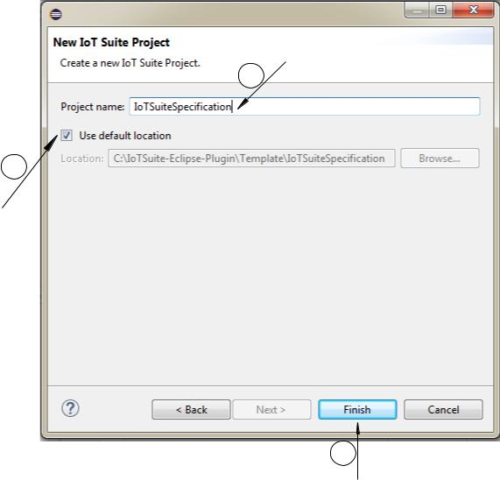

Write Project name:

IoTSuiteSpecification

1

2

Check Use default location

3

Click on Finish button

Figure 7: IoTSuite Project Creation Wizard (2)

23

As a result, new IoTSuite project is created, and the corresponding IoTSuite specification files will be opened in Xtext mode. By default, they have predefined contents in order to guide developers. The structure of created project is shown in Figure 8. Once the IoTSuiteProject is created, next step is to specify high-level specification (Refer Section 7.3.1).
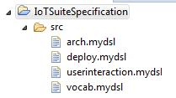

Figure 8: IoTSuite Project Structure

7.3.1 Specifying high-level specifications

- Specifying high-level specification using editor: To write these specifications, we present Xtext for a full fledged editor support with features such as syntax coloring, error checking, auto completion, rename re-factoring, outline view and code folding.

- We have implemented Outline/ Structure view feature which is displayed on top most right side of the screen (Refer Figure 9). It displays an outline of a file highlighting its structure. This is useful for quick navigation.

- As shown in Figure 9, in your vocab.mydsl file if you have a large number of structures, sensors, and actuators, than from outline by just clicking on particular structures (e.g. TempStruct) it navigates to TempStruct definition in the vocab.mydsl. So, developers don’t need to lookup in entire file.

- Using syntax coloring feature, keywords are appeared in colored text (Refer Figure 10).

- Using code folding, developer can collapse parts of a file that are not important for current task. In order to implement code folding, click on dashed sign located in left most side of the editor. When developer clicked on dashed sign, it will fold code and sign is converted to plus. In order to unfold code, click again on plus sign. As shown in Figure 11, we have fold code for TempStruct, HumidityStruct, and BadgeStruct.

- The error checking feature guides developer if any error is there. General error in the file is marked automatically e.g., violation of the specified syntax or reference to undefined elements. Error checking indicates if anything is missing/wrong in particular specification file where Auto Completion helps developer to complete entire word/statement.

- Auto completion is used to speed up writing text in specification files. In order to use auto completion feature, developer need to press ctrl+space key at current cursor position, so it will

24

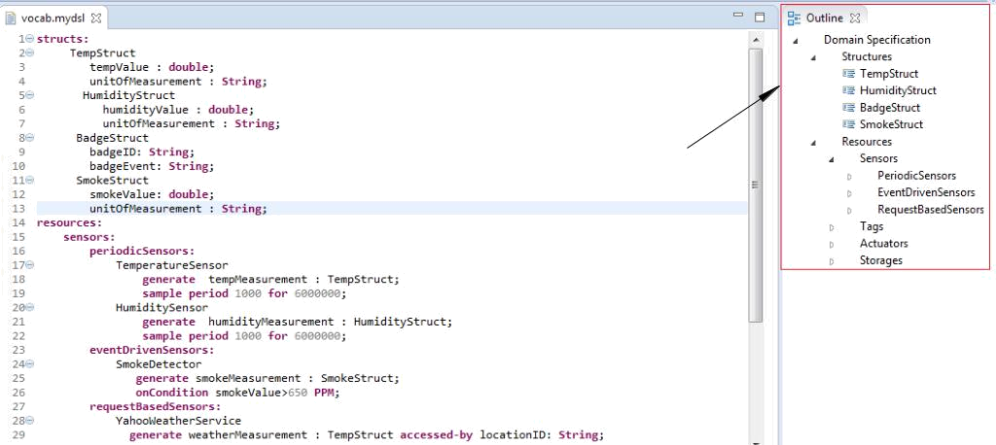

Outline view

Figure 9: IoTSuite editor feature: Outline view
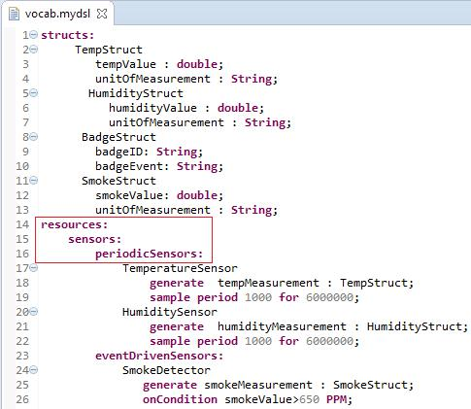

Syntax coloring

Figure 10: IoTSuite editor feature: Syntax coloring

provide suggestion. Here (Refer Figure 12), in TemperatureSensor definition if we write T and press ctrl+space than it will suggest us to write TempStruct.

25

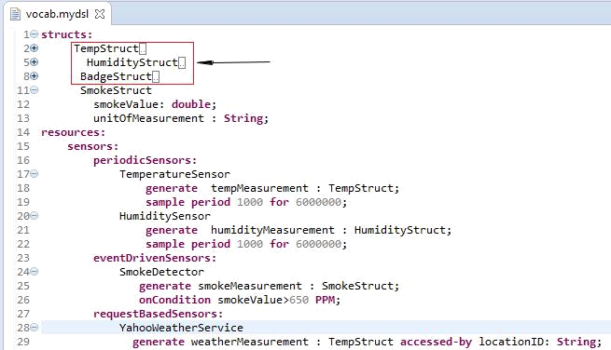
Code folding

Figure 11: IoTSuite editor feature: Code folding
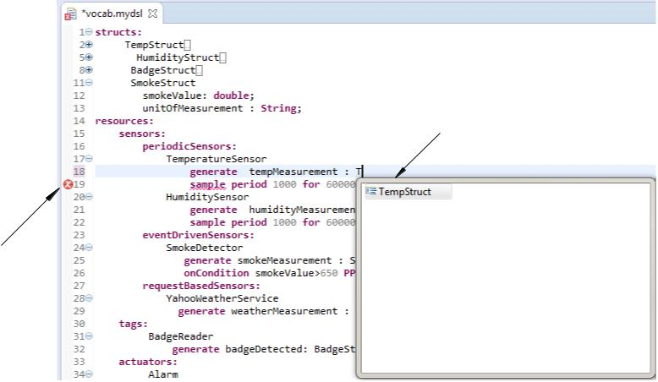

Auto completion

Error checking

Figure 12: IoTSuite editor features: Error checking & Auto completion

– Specifying domain specification

Developer specifies domain specification using vocab.mydsl file. To do this, double click on vocab.mydsl (Step 1) and write domain specification using IoTSuite editor (Step 2) as shown in Figure 13.

26

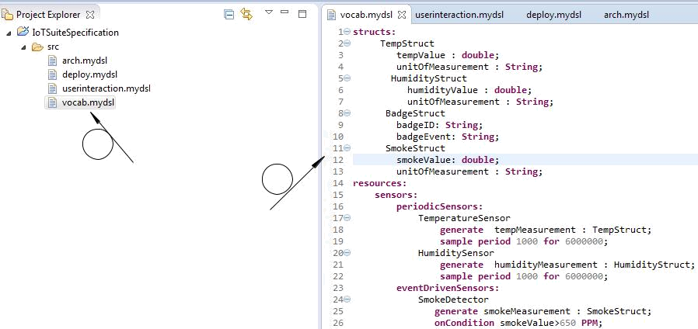

1
Double click on | 2
vocab.mydsl | 2
 | Editor area for writing
 | vocabulary specification

Figure 13: Domain Specification

– Specifying arch specification

Now, developer specifies architecture specification using arch.mydsl. To specify architec-ture specification, double click on arch.mydsl (Step 1) and write architecture specification using IoTSuite editor (Step 2) as shown in Figure 14.
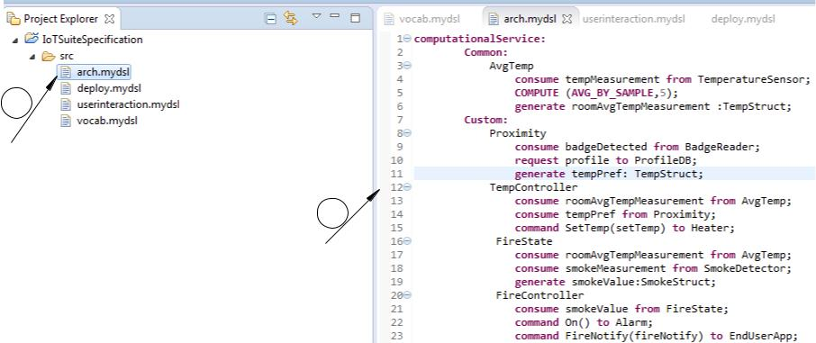

1

Double click on arch.mydsl

2

Editor area for writing architecture specification

Figure 14: Architecture Specification

– Specifying user-interaction specification To specify user-interaction specification, developer double click on userinteraction.mydsl, and write user-interaction specification using IoTSuite editor (Step 2) as shown in Figure 15.

27

1

Double click on userinteraction.mydsl

2
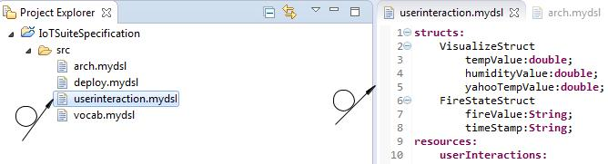
Editor area for writing userinteraction specification

Figure 15: User-Interaction Specification

– Specifying deployment specification

Developer specifies deployment specification using deploy.mydsl. To do this, double click on deploy.mydsl and write deployment specification using IoTSuite editor (Step 2) as shown in Figure 16.
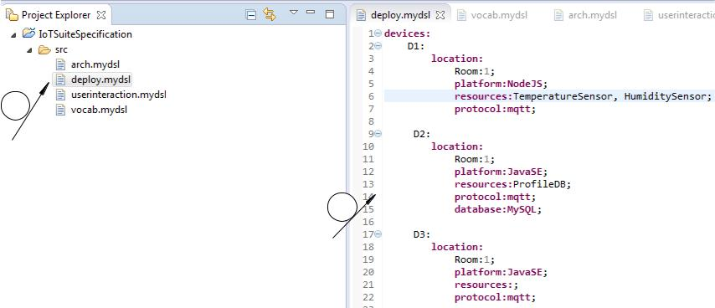

1

Double click on deploy.mydsl

2

Editor area for writing deployment specification

Figure 16: Deployment Specification

- Compilation of an IoTSuite Project

Now, we need to compile the high-level specification written by developer in Section 7.3.1. To do so, we generate programming framework, by performing following Steps:

- Compilation of high-level specification

• Compilation of vocab specification- Right click on vocab.mydsl file (Step 1) and selecting "Compile Vocab" (Step 2) (Refer Figure 17) generates a vocabulary framework.

28

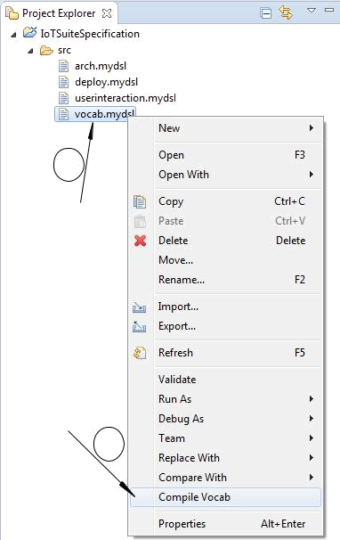

1

Right click on vocab.mydsl

Click on
Compile Vocab

2

Figure 17: Compilation of Vocab specification

• Compilation of architecture specification- Right click on arch.mydsl file (Step 1) and selecting "Compile Arch" (Step 2) (Refer Figure 18) generates an architecture framework.
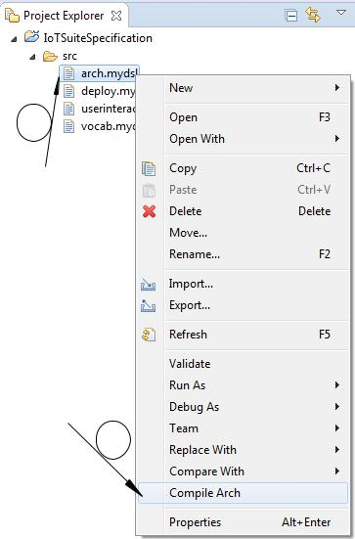

1

Right click on arch.mydsl

Click on
Compile Arch

2

Figure 18: Compilation of Architecture specification

29

- Import application logic package- To import application logic package, click on File Menu (Step 1), and select Import option (Step 2) as shown in Figure 19.
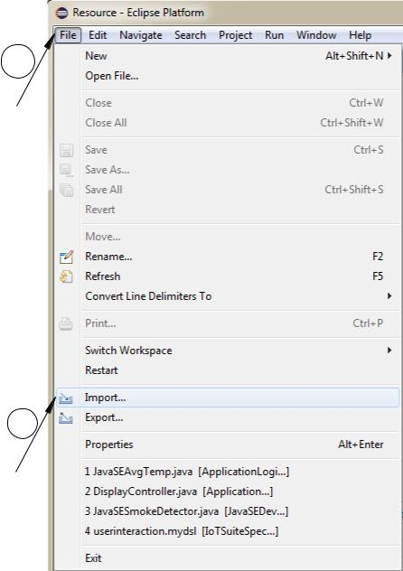

1

Click on File

2

Click on Import

Figure 19: Import application logic package

- Locate application logic package- To locate application logic package, browse to Template path (Step 1), select application logic package (Step 2), and click on Finish button (Step 3) as shown in Figure 20.
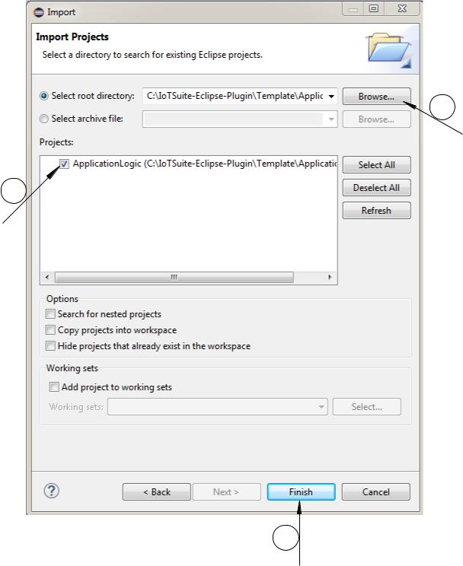

1

Browse to
Template path

2

Select Application
Logic

3

Click on Finish

Figure 20: Locate application logic package

30

• Implementing application logic- To implement application logic refer [7, p. 12-13].
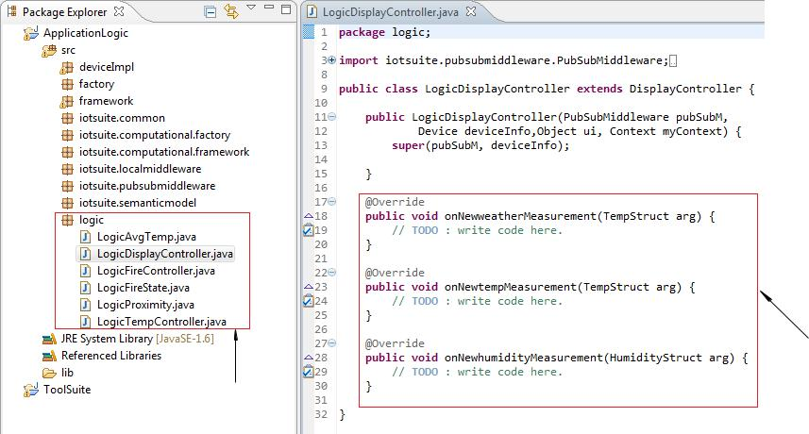

Implement abstract methods

Implement
Application Logic

Figure 21: Implement application logic package

- Compilation of user-interaction specification- Right click on userinteraction.mydsl file and selecting "Compile UserInteraction" (Refer Figure 22) generates a User Interaction (UI) framework.
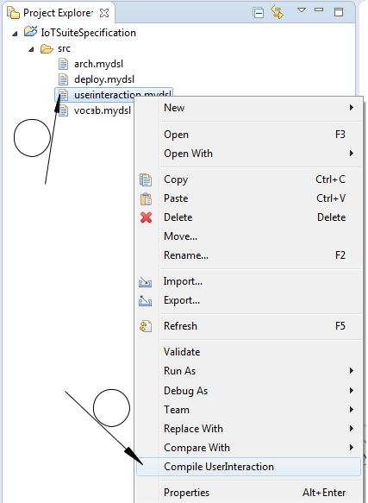

1

Right click on userinteraction. mydsl

Click on Compile
UserInteraction

2

Figure 22: Compilation of User-Interaction specification

31

- Compilation of deployment specification- Right click on deploy.mydsl file and selecting "Compile Deploy" (Refer Figure 23) generates a deployment packages.
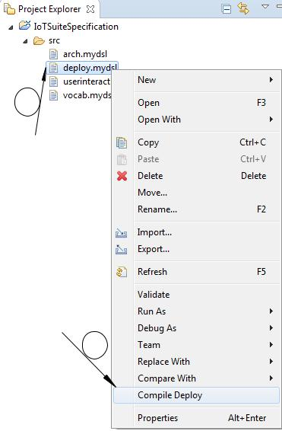

1

Right click on deploy.mydsl

Click on
Compile Deploy

2

Figure 23: Compilation of Deployment specification

- Import user-interface project - To import user-interface project, click on File Menu (Step 1), and select Import option (Step 2) as shown in Figure 24.

1

Click on File

2

Click on Import

Figure 24: Import user-interface project

32

- Locate user-interface project- To locate user-interface project, browse to CodeForDeployment folder in Template path (Step 1), select project specified in the use-interaction specification (Step 2), and click on Finish button (Step 3) as shown in Figure 25.
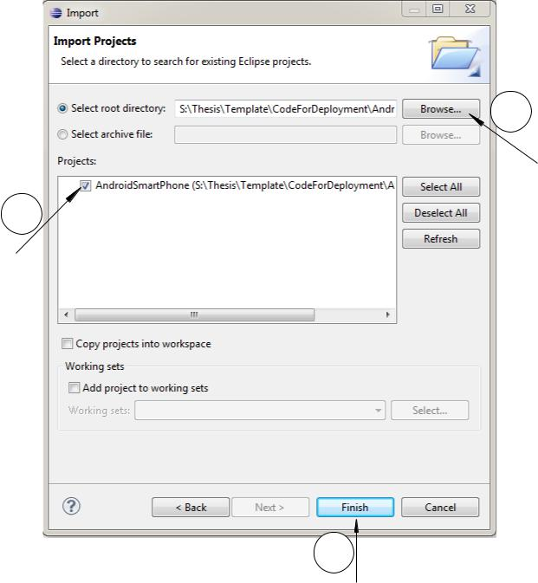

1

Browse to CodeForDeployment
₂ folder in Template path

Select User-Interface

project

3

Click on Finish

Figure 25: Locate user-interface project

• Implementing user-interface project- To implement user-interface project refer [7, p. 15-16].
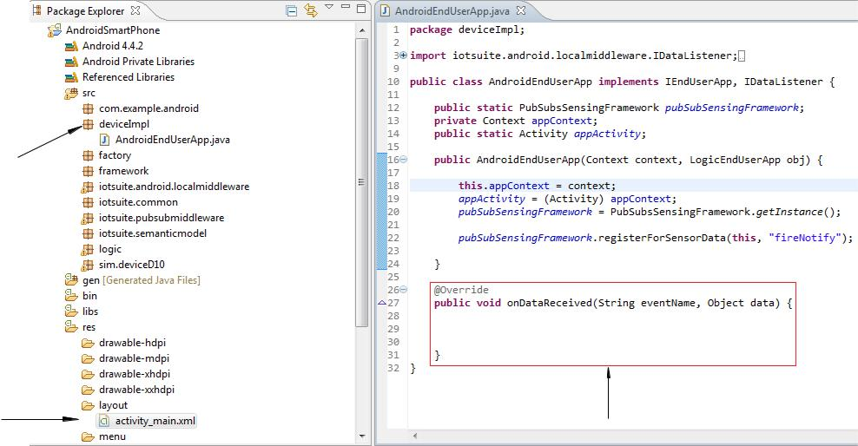

Implement User

Interafce Code

Define UI | Implement
element | Implement
element | abstract method

Figure 26: Implement user-interface project

33

7.5 Deployment of generated packages

- The output of previous Step (compilation of deployment specification) produce a set of platform specific project/packages (Figure 27) for devices, specified in the deployment specification (Refer Figure 16). These projects compiled by device-specific compiler designed for the target platform. The generated packages integrates the run-time system, it enables a distributed execution of UI Automation applications.
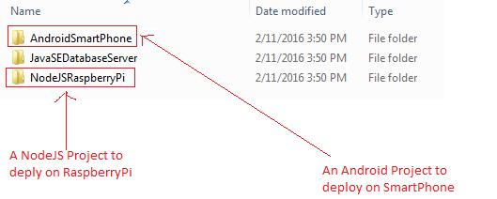

Figure 27: Packages for target devices specified in the deployment specification

34

- Evaluation

The goal of this section is to describe how well the proposed approach eases the UI Automation application development compared to the existing approaches (discussed in Section 1.3). We implemented the smart home application (discussed in Section 1.1) using existing approaches.
Metrics for evaluation To evaluate the proposed approach, we employed the lines of code (LoC) as metrics to measure the development eﬀort. We are aware that LoC is not a precise metrics and it depends on programming languages, styles and stakeholders’ programming skills. However, it provides an approximate measurement of development eﬀort. We measured development eﬀort using Eclipse Metrics 1.3.6 plug-in⁴. This tool counts actual Java statement as LoC and does not consider blank lines or lines with comments.

Entities | Component(model) | Interaction | Runs on
 |  | mode
 | Temperature(AM2302) | Periodic | RaspberryPi
Sensor | Humidity(AM2302) | Periodic | RaspberryPi
 | Smoke(MQ2) | Event | Arduino
Actuator | Heater(using LCD) | Cmd | RaspberryPi
Actuator | Alarm(using buzzer) | Cmd | RaspberryPi
Tag | BadgeReader(RFID-RC522) | Event | RaspberryPi
WebService | Yahoo Weather | Req./Resp. | Yahoo Server
End-user | EndUserApp | Notify | AndroidPhone
Interac- | DashBoard | Notify | Desktop
tion
Storage | ProfileDB(MySQL) | Req./Resp. | Microsoft Cloud
Computation | Proximity & others | Event, | Cmd, Desktop
 |  | Req./Resp.

Table 2: Smart home application implementation

Setup for experiments We selected the smart home application as a case study for the evaluation, implemented it with the following existing approaches, and compared them with our approach: (1) GPL: We have implemented application-specific functionality using general-purpose programming languages such as Node.js, HTML, Android, and JavaScript. (2) Cloud-based Platform: As a representative tool for cloud-based platforms, we selected Node-RED⁵. It is a widely popular visual tool for wiring together hardware devices, APIs and online services. It provides a flow editor where developers can drag-and-drop nodes and configure them using dialog editor to specify appropriate properties. To calculate the LoC using Node-RED, we counted each configuration specification as one line of code. We intentionally omitted WSN macro-programming approaches in the comparison because these approaches largely focus on similar types of devices and their main purpose largely is to sense data only. Therefore, WSN macroprogramming systems may not be suitable for evaluation, given UI Automation application execute on heterogeneous entities.
We set up a real execution environment that is made up of entities, exhibiting heterogeneity discussed in Section 1.2. Table 2 shows entities used to perform the evaluation. All three approaches have been implemented and tested on this setup.

⁴http://metrics.sourceforge.net/
⁵http://nodered.org/

35

Results Table 3 shows the LoC required to develop the case study using all three approaches. Using GPL, the stakeholders have to write more than twice number of LoC compared to Node-RED to implement the same application (57% eﬀort reduction compared to GPL). The primary reason of eﬀort reduction is that Node-RED provides high-level constructs that hides low-level details.

Approch. |  | S | A | T | WS | EU | ST | Comp. |  | Total
GPL |  | 51 | 40 | 9 | 19 | 211 | 36 | 267 |  | 633
Node-RED |  | 51* | 40* | 9* | 0 | 39 | 14 | 118 |  | 271
MDD |  |  | 40(Vocab. Spec.)+29(Arch. Spec.)+ |  |  |  |  |  |  | 188
(IoTSuite) |  |  | 43(Deploy. Spec.)+14(User Interaction Spec.)
 |  |  | +26(App. Logic code)+36(User Interface Code)

Table 3: Comparison of existing approaches: Lines of code required to develop the smart home application. S (Sensor), A (Actuator), T (Tag), WS (External Web Service), EU (End user Application), ST (Storage),Comp. (Computational Services).

Cloud-based platform is a viable approach compared to the GPL. It reduces the development eﬀort by providing cloud-based APIs to implement common functionality. However, one of Node-RED drawbacks is its node-centric approach. The stakeholders have to write code to implement platform-specific functionality such as reading values from sensors, and actuating actuators. For Node-RED, nodes for sensors and actuators are contributed at public repository ⁶. However, many nodes are not available in the library till May 19, 2016, marked as * in Table 3. This leads to a platform-dependent design and increases the development eﬀort.

Table 3 shows that stakeholders can write the same application using our approach in 188 LoC (70% eﬀort reduction compared to GPL and 30% eﬀort reduction compared to Node-RED). The reason is that our approach provides the ability to specify an application at global-level rather than individual devices. For instance, the domain language provides abstractions to specify entities in platform-independent manner. The translation of this specification to platform-specific code is taken care by our approach. So, the stakeholders do not have to write platform-specific code while developing an application.

⁶http://flows.nodered.org/

36

- Real time PT 100 sensor data visualization using RIO600

The goal of this experiment is to utilize the capability of ABB devices and tools to enable development of UI Automation application. To enable the real time (streaming) visualization, we used ABB devices such as RIO 600, REF 620 (IED) and ABB tools such as PCM600, Micro-SCADA. RIO600 is used to extent the capability of sensing/actuating entities and enable communication with other entities using GOOSE and Modbus communication protocol. Several units can connected to read or write analog/digital value. The RTD module is used to read analog value, DIM module is used to read digital value, and DOM module is used to write digital value.

IED REF 620 RIO600 with RTD module
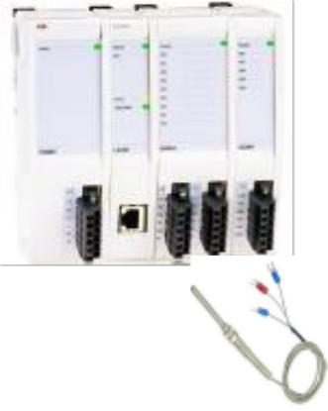
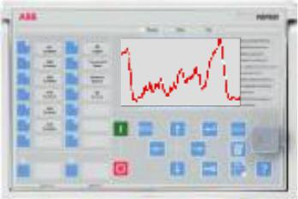

GOOSE communication


PT100 temperature sensor

Figure 28: Architecture of the system

The architecture of the system is shown in Figure 28. The system consists of PT 100 temperature sensor, RIO600 with RTD module, and REF 620 (IED- Intelligent electronic device). PT 100 temperature sensor connected with RTD module (compatible with RTD module) is used to measure the temperature value between -40 C to +200 C. The RTD (analog module) reads the value of PT 100 temperature sensor. Once the PT 100 temperature sensor is connected to RTD module, stakeholders need to configure the parameter of RIO600 as shown in Figure 29. Referring Figure 29, first stakeholders have to create new project in PCM600, add RIO600, REF 620 IED used in the setup. Once the project is created stakeholders have to set the parameter configuration of RTD module. This configuration includes information about what channels are used (e.g., sensor is connected to which Channel), input mode (e.g., type of the sensor), conn type (whether it is a two wire or three wire connection), Value unit (whether sensor reads value in degree Celsius or Fahrenheit), and min-max value. Once this configuration is done, stakeholders have to write this configuration to RIO600 (this is required to update default configuration of RIO600).

The next step is to specify communication configuration. First, stakeholders need to identify publisher/subscriber available in the same network. Stakeholders configure such configuration using IEC 61850 configuration of RIO600 as shown in Figure 30. Referring Figure 30, stakeholders have to

37

enable options that what kind of value (analog or binary) RIO600 publish through GOOSE and who is the subscriber. Here RIO600 publish both analog and binary data and subscribe by LD0 (i.e. REF 620).
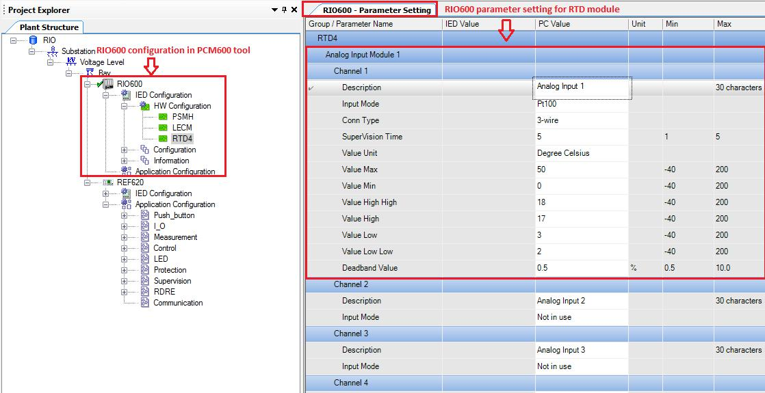

Figure 29: RIO600 parameter configuration for RTD module using PCM600
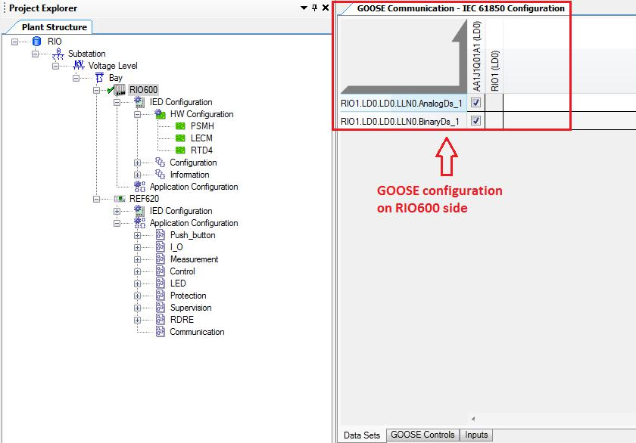

Figure 30: GOOSE communication configuration on RIO600 side

Once the GOOSE configuration is done on RIO600 side using PCM600, stakeholders have to configure signal matrix of REF620. Here they have to provide information about what channel

38

are they looking to subscribe for the data. This channel number should be mapped with publisher channel number as shown in Figure 29. Here, publisher (RIO600) publish data using Analog channel 1 (ref Figure 29) and subscriber (REF620) subscribe for the data using the same channel (i.e. Analog Channel 1, ref Figure 31).
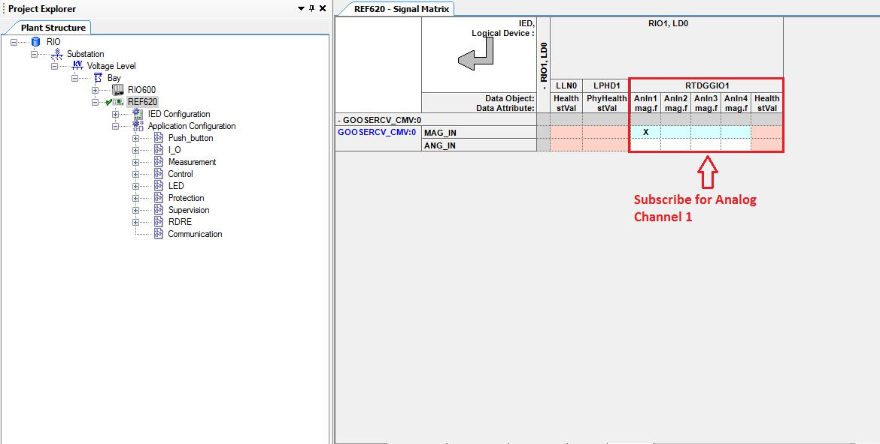

Figure 31: Signal Matrix to subscribe for Analog Channel 1

The stakeholders map the subscribe value using GOOSE communication to the subscriber input (REF620) as shown in Figure 32.
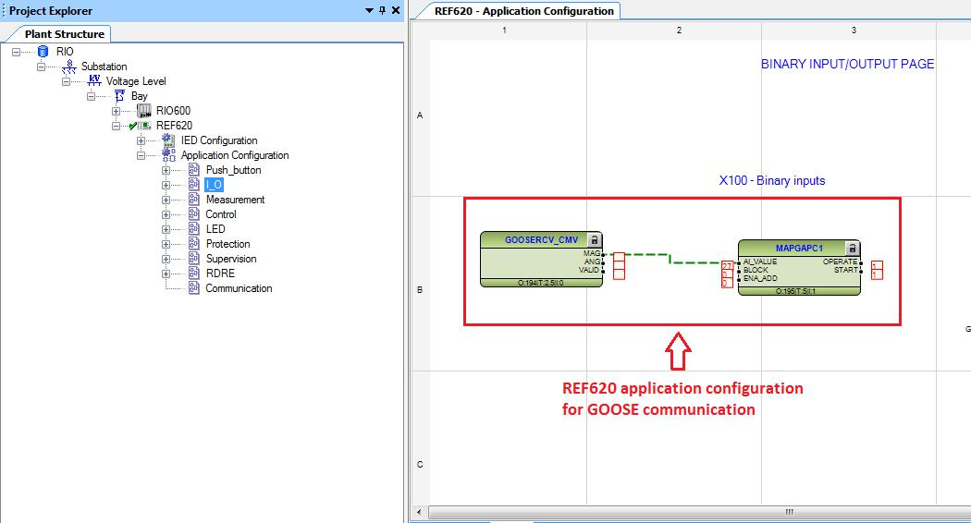

Figure 32: Mapping GOOSE configuration in REF620

Stakeholders visualize the data in form of trends or value. The RIO600 is equipped with web-interface, which display the real time temperature sensor value as shown in Figure 33. The Micro-SCADA (ABB measurement tool) is used to enable the functionality of real time visualization

39

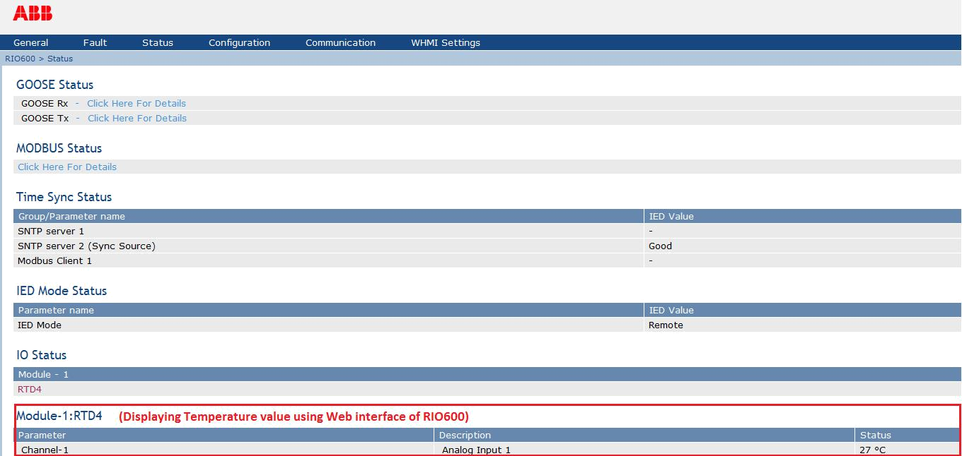

Figure 33: Displaying temperature value through web-interface of RIO600

of PT 100 temperature sensor. It allows the stakeholders to set axis legends, axis name, and also provide the summary of trend as shown in Figure 34. The Micro-SCADA also allows the stakeholders to export data to .CSV file or MySQL database which is used for further analysis.
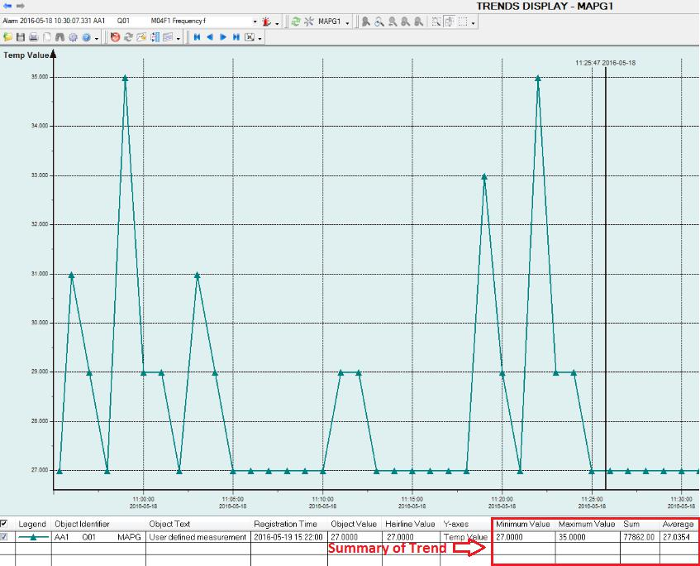

Figure 34: Displaying Trend using Micro-SCADA

40

10 Conclusion and Future work

We have built upon our existing framework and evolved it into a framework for developing UI Automation applications, with substantial additions and enhancements such as describing heterogeneous entities and end-user interactions. We present a comparative evaluation results with existing approaches. This provides the UI Automation community for further benchmarking. The evaluation is carried out on real devices exhibiting UI Automation heterogeneity. Our experimental analysis and results demonstrates that our approach drastically reduces development eﬀort for UI Automation application development compared to existing approaches.

Our immediate future work will be to evaluate the usability of this development framework. This will help us to assess the potential for transferring it to industrial environment for UI Automation domain.

41

References

- G. R. Andrews. Paradigms for process interaction in distributed programs. ACM Comput. Surv., 23(1):49–90, Mar. 1991.

- E. Balland, C. Consel, B. N;Kaoua, and H. Sauzéon. A case for human-driven software develop-ment. In Proceedings of the 2013 International Conference on Software Engineering. IEEE Press, 2013.

- M. Blackstock and R. Lea. Wotkit: A lightweight toolkit for web of things. In Proceedings of the Third International Workshop on Web of Things. ACM, 2012.

- D. Cassou, J. Bruneau, C. Consel, and E. Balland. Toward a tool-based development methodology for pervasive computing applications. IEEE Transactions on Software Engineering, 38(6):1445– 1463, 2012.

- V. Kulkarni and S. Reddy. Separation of Concerns in Model-Driven Development. IEEE Software, 20(5):64–69, 2003.

- R. Newton, G. Morrisett, and M. Welsh. The regiment macroprogramming system. In Proceedings of the 6th international conference on Information processing in sensor networks. ACM, 2007.

- P. Patel and D. Cassou. Enabling high-level application development for the UI Automation.

Journal of Systems and Software, 103:62 – 84, 2015.

- E. Serral, P. Valderas, and V. Pelechano. Towards the model driven development of context-aware pervasive systems. Pervasive and Mobile Computing, 6(2):254–280, 2010.

- J.-P. Vasseur and A. Dunkels. Interconnecting smart objects with IP: The next internet. Morgan Kaufmann, San Francisco, CA, USA, 2010.

42

